**RV College of Engineering®, Bengaluru – 59**

**Department of Computer Science and Engineering**

**Database Design Laboratory (18CS53)**

**Requirement specification**

|  |  |  |
| --- | --- | --- |
| **TITLE: Student Achievement Web App** | | |
| **TEAM** | USN: 1RV18CS142 | Name: Sai Keerthana |
| USN: 1RV18CS143 | Name: Sakshi Kamal |

**1.** **Hardware Specification**

· Pentium IV or higher, (PIV-300GHz recommended)

· 256 MB RAM

· 1 Gb hard free drive space

**2.** **Software Specification**

· React+Bootstrap+HTML+CSS (front end)

· JavaScript

· Visual Studios

· Web Browser: Microsoft Internet Explorer, Mozilla, Google Chrome or later

· MySQL Server + NoSQL(back-end)

· Operating System: Windows XP / Windows7/ Windows Vista

**3. Functional Requirements**

* Insert Record:

Adding achievements of any type. This function is restricted to students and teachers only. This functionality typically consists of type of achievement, essential details and date.

* Update Record:

Updating of achievements is also restricted to students and teachers only. It is essential as inserting might be prone to human errors or there might be an important change to make.

* Delete Record:

This functionality is restricted to students and teachers. In case of a mistake or in case a certain achievement reaches expiration (for eg, a certain course having a limited timeframe).

* Generate Report:

This functionality can be accessed by any user. It essentially is used to generate a report of all the achievements of a particular student at any point in time.

* Read Record:

This functionality is specifically for the recruiters wherein they can only view the achievements of students and cannot tamper with it.

* Recruitment Process-

A recruiter will approach the department they want and ask the admin for access to this web app. The admin will then give them a temporary login ID and password. Post this, the recruiter can view the achievements and progress of all students concerned(this ideally may happen after an initial screening round by the recruiter).

Since all the essential details of all students are aggregated in one secure place unnecessary tampering or misplacing will reduce drastically and more importantly, this entire process becomes much more transparent.

After a particular student is hired or shortlisted, on their profile this tag will be visible. This is essential to avoid overlapping if more than one recruiter is interested in one particular student at any given time.

ER Diagram:

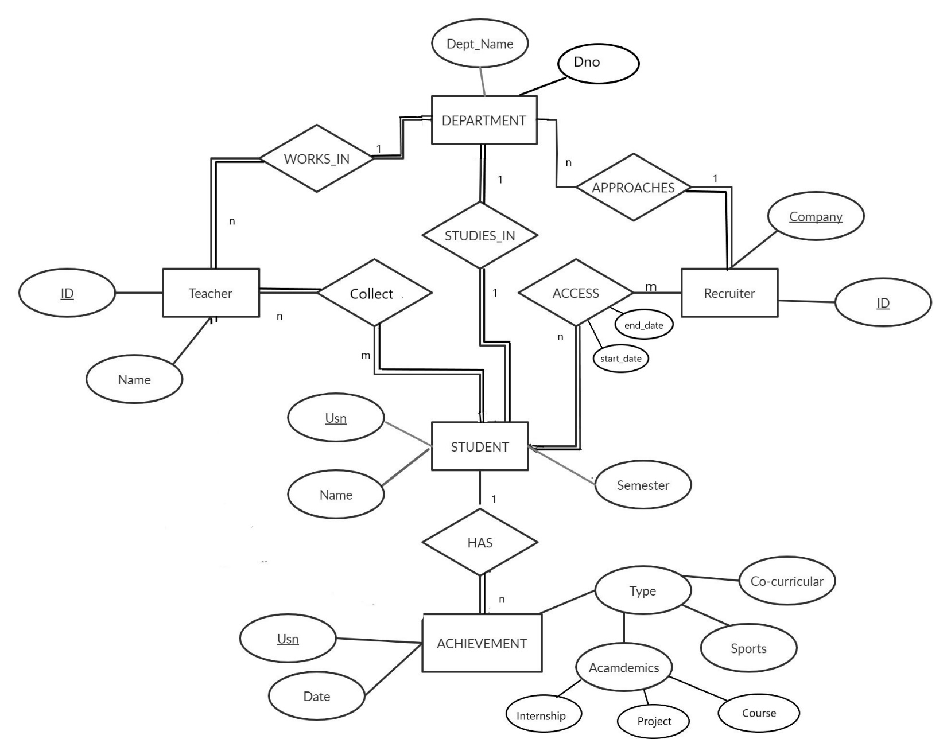

**Explanation:**

* Every student is identified by Usn, Name and Semester, studies under one department, and has zero or more achievements. Every student can store, update, delete their achievements.
* Achievements are related to students. Each achievement is characterized by the student Usn, date and the type. The type may be Academic, Sports or Co-curricular. Academics can further be divided into Internship, Project and course.
* Every Department is identified by Dept_name and has teachers working and students studying in it.
* Every teacher works in a department and is characterized by ID and name. Each teacher can manage the student achievements of students under them and can retrieve the data achievements of a particular student.
* A Recruiter approaches a particular department for the recruitment process, and the access to student achievements is allowed accordingly.